**Defining the Adiame project structure with Maven**

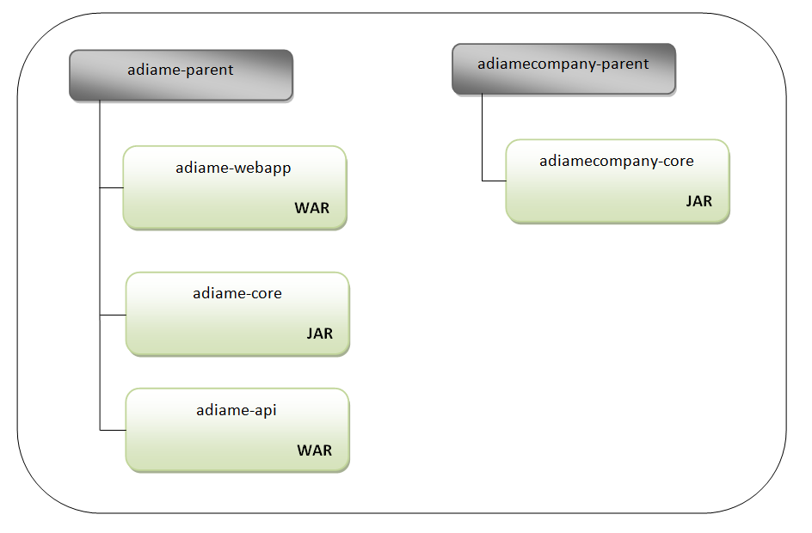Here, we will focus on defining, with Maven, the project structure we need for our application (Adiame).

* The application project adiame-parent will have three modules. Two of them will be packaged as web archives (war): the main web application (adiame-webapp) and the REST API (adiame-api). One of them will be packaged as a jar dependency (adiame-core).
* The company-specific project adiamecompany-parent will have only one sub-module (adiamecompany-core), which will be packaged as jar.